Hard copies of Sources/Texts for each station:
- Textbook: Feldman, K. (2004). Eastern hemisphere: Geography, history, culture. Needham, Mass: Pearson.
- Excerpt fromPilkington, D. (1996). Follow the rabbit-proof fence. St. Lucia, Qld.: University of Queensland Press.
- Blog: Ruthmann, A. (2012). Ask Anne: What's it like to live in Australia? Retrieved September 24, 2015
- Children’s book: Berkes, M., & Dubin, J. (2011). Over in Australia: Amazing animals Down Under. Nevada City, CA: Dawn Publications
- Excerpt from Young Adult Novel: Christopher, L., & Wells, S. (2010). Stolen. New York: Chicken House/Scholastic.
- Non-fiction text: Ganeri, A. (2014). Australia. Chicago, Illinois: Heinemann Library.
- Children’s novel: Stilton, G. (2007). Down and out down under. New York: Scholastic.
- Non-fiction text: Turner, K. (2007). Australia. Washington D.C.: National Geographic.
- Transcript of campaign speech by John Curtin, 1937. (n.d.). Retrieved September 24, 2015
- Video: Green, H. (2013). Marine Pollution in Australia Infographics. Retrieved September 23, 2015, from YouTube. https://www.youtube.com/watch?v=gMt_wyAjzAU
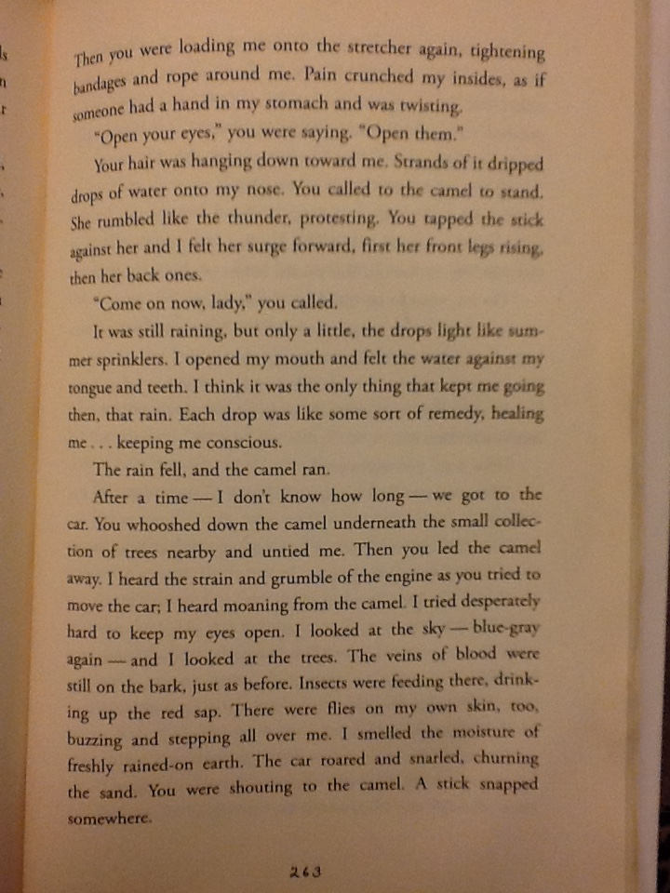
Except from Stolen by Lucy Christopher
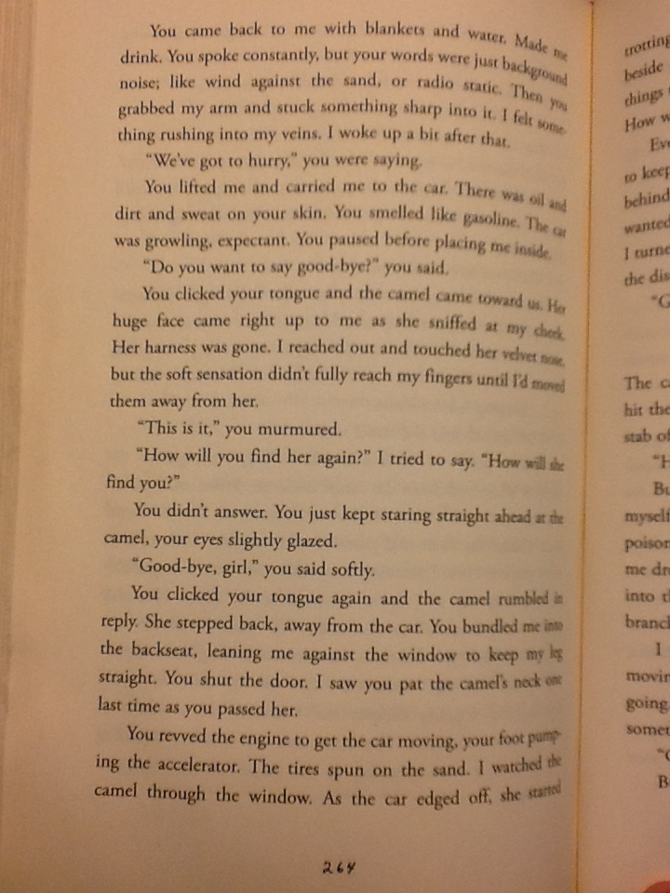
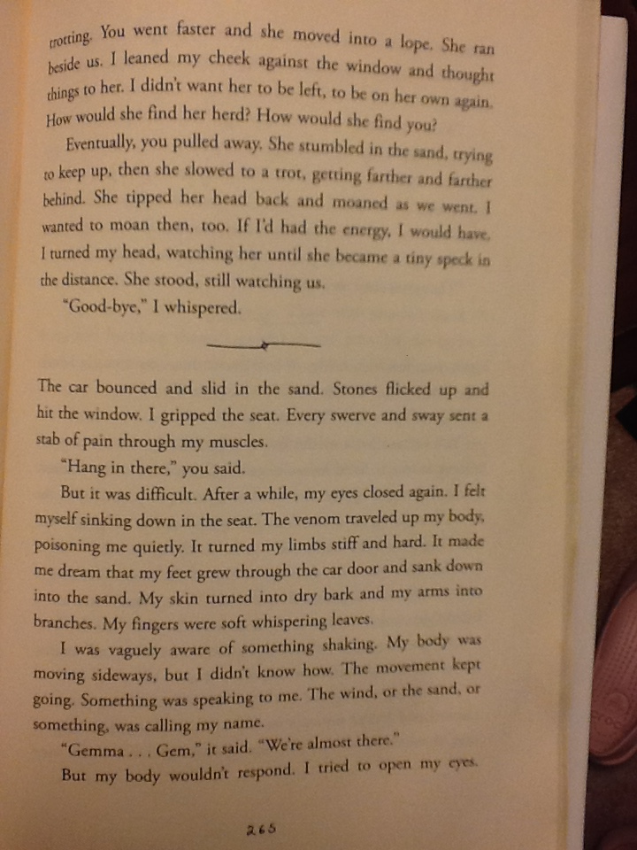
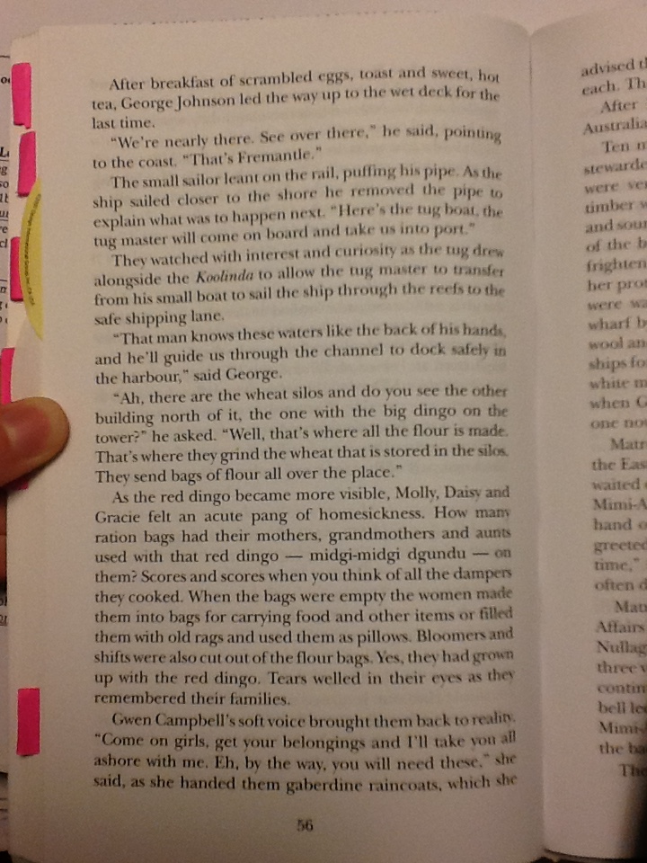
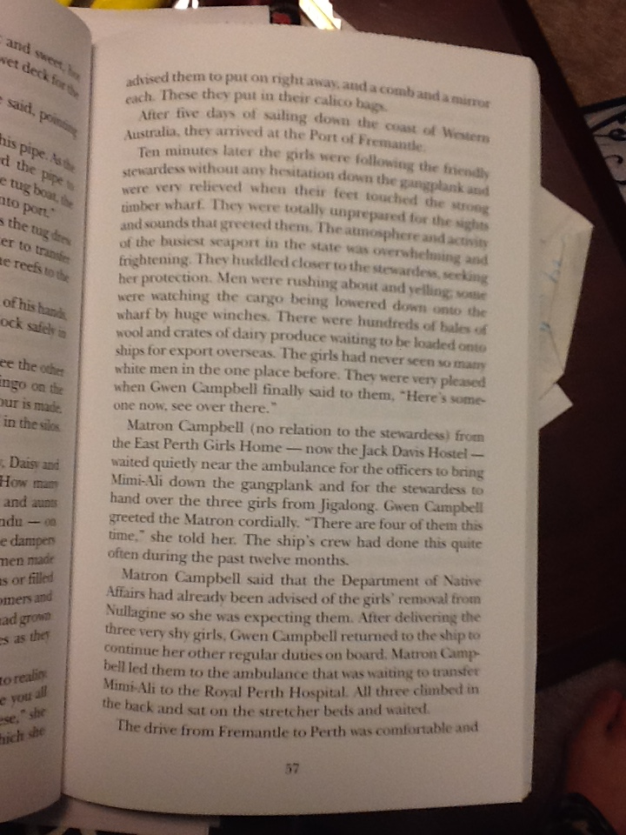
Excerpt from Follow the Rabbit-Proof Fence by Doris Pilkington and Nugi Garimara

