Name:__________________________________________ Date:______________ Period:______

Australian Geography DBQ
Grade 6
The following question is based on the accompanying documents. This question is designed to test your ability to work with historical documents. As you analyze the documents, take into account both the source of the document and the autor’s point of view.

What is the relaitonship between the Europeans and the Aborigines?

Task:
- For Part A, read each document carefully and answer the questions after each document. The questions can be answered only using the information gained from the documents. After each section, write down your thoughts and comments about what the section’s topic says about the relationship between the Europeans and the Aborigines.
- For Part B, use your answers from part A, information from the documents, and your knowledge of social studies to write a well organized essay.
PART A
1967 Federal Referendum
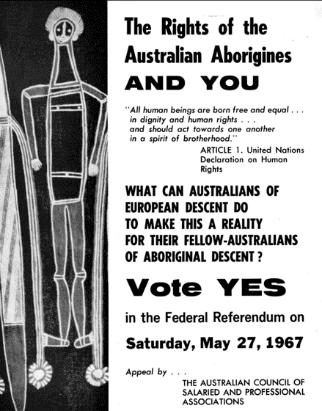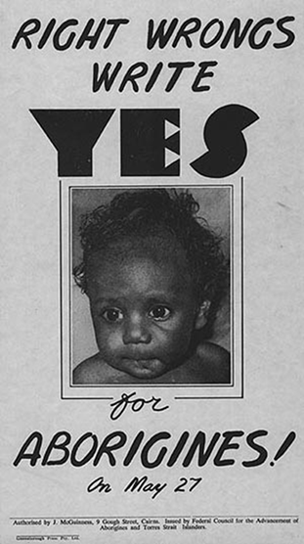

- What are these advertisements promoting?
______________________________________________________________________________________________________________________________________________________________________________________
- Why do the posters say Australians should vote yes?
______________________________________________________________________________________________________________________________________________________________________________________

The 1967 Federal Referendum was more about symbolism than substance. It was sold as a gesture of goodwill towards Aborigines. In hindsight, it seems symbolism and gestures of goodwill were not sufficient to stop Aborigines being defined by statistics of disadvantage. The goodwill existed. The logical plan did not.
Not all Aborigines were happy with the result of the referendum either. The chairman of the Northern Land Council, Mr Galarrwuy Yunupingu said:
- The historic 1967 referendum - where Australians voted overwhelmingly to make Aborigines citizens and for federal government powers to legislate on their behalf - had been forced upon the Aboriginal nation.
- Aboriginal people have never wanted to be equal with the white people of Australia.
- The referendum had been inspired by guilt and had never considered the rights we Aboriginal people really had, or who we really were.

- What inspired the 1967 Federal Referendum?
______________________________________________________________________________________________________________________________________________________________________________________
- What did Mr. Galarrwuy Yunupingu, an Aborigine, dislike about the Federal Referendum?
______________________________________________________________________________________________________________________________________________________________________________________
Write down your thoughts and comments related to the following question: What does the 1967 Federal Referendum documents say about the relationship between Europeans and Aborigines?

The British Justice System
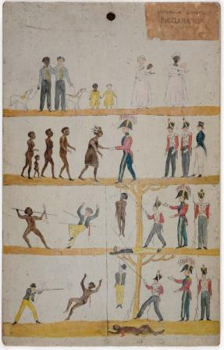
Posters erected in Tasmania in the early 19th century. The posters aimed to communicate that blacks and whites would be treated equally by the British justice system.
  - What did the men do that lead to being hanged?
__________________________________________________________________________________________________________________________________________________________________________
  - What are the men, In the middle of the third level from the bottom, doing?
__________________________________________________________________________________________________________________________________________________________________________
The white settlers were a protected species; they were safe with their own laws and had police and soldiers to enforce these rules.
One evening, Moody, Yellagonga’s uncle, brought back some distressing news from the people at the Lake Monger and the Nyungar people knew their lives were in serious danger. “A big meeting was held there last week and one man was punished for breaking the white man’s law and the troopers came down and took several men away.”
It became apparent then, that the Aboriginal social structure was not only crumbling, but it was being totally destroyed.
“It seems,” added Moody, “that our laws are not being recognized by these strangers.” The Nyungar people were hurt and confused when they were punished for carrying out their own traditional laws, handed down to them by the Dreamtime spirit beings.
”Yet when old man Udja complained to the magistrate that a white man stole his wife, Nella, he was given a bag of flour and told to go home,” Moody reminded them. “That old man expected the same form of justice under the white man’s law. He never got it.”
Excerpt from Follow the Rabbit Proof Fence, page 15.
- What happened when an Aborigine broke the white man’s law?
______________________________________________________________________________________________________________________________________________________________________________________________________________________________________________________
- What happened when a white man stole an Aborigine’s wife?
______________________________________________________________________________________________________________________________________________________________________________________________________________________________________________________
Write down your thoughts and comments related to the following question: What does the British Justice System documents say about the relationship between Europeans and Aborigines?

The Stolen Generations

The Stolen Generations (also known as Stolen Children) were the children of Australian Aboriginal and Torres Strait Islander descent who were removed from their families by the Australian Federal and State government agencies and church missions, under acts of their respective parliaments.
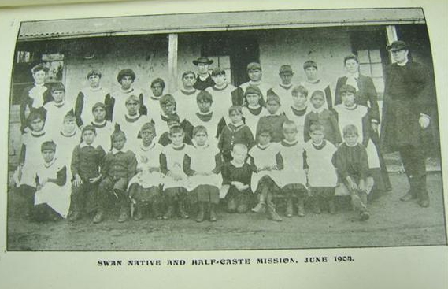
Caption reads “Swan Native and Half-Caste Mission, June 1904”

- What year was this picture taken?
______________________________________________________________________________________________________________________________________________________________________________________

- What kind of Australian’s a present in the photograph?
______________________________________________________________________________________________________________________________________________________________________________________

The common belief at that time was that part Aboriginal children were more intelligent than their darker relations and should be isolated and trained to be domestic servants and laborers. Policies were introduced by the government in an effort to improve the welfare and educational needs of these children. Molly, Daisy, and Gracie were completely unaware that they were to be included in the schemes designed for children who were fathered by white men.
Excerpt from Follow the Rabbit Proof Fence, page 40.

- Who are the “stolen generation”?
_________________________________________________________________________________________________________________________________________________________________________________________________________________________________________________________________________________
- Why were part Aboriginal children taken?
_________________________________________________________________________________________________________________________________________________________________________________________________________________________________________________________________________________
Write down your thoughts and comments related to the following question: What does the Stolen Generation documents say about the relationship between Europeans and Aborigines?

The Rabbit Proof Fence
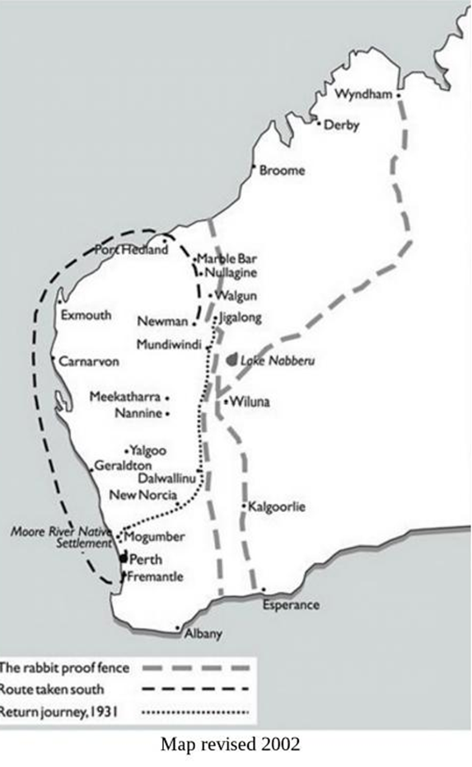
The rabbits adapted to this hot arid land immediately and they thrived and multiplied at an alarming rate. In an attempt to control the rabbit population, the rabbit-proof fence was constructed and completed in 1907. In Western Australia the fence covered a distance of 1,834 kilometers and ran from the Southern Ocean near the port of Esperance in the south to the tropical Eighty Mile Beach north of Port Hedland. The government of the day proposed that a properly constructed and well-maintained fence of barbed wire would halt the invasion of rabbits into Western Australia from the eastern states.
Excerpt from Follow the Rabbit Proof Fence, page 32.
- Why was the rabbit proof fence constructed?
______________________________________________________________________________________________________________________________________________________________________________________________________________________________________________
- How long was the rabbit proof fence?
______________________________________________________________________________________________________________________________________________________________________________________________________________________________________________
The Nyungar people, and indeed the entire Aboriginal population, grew to realize what the arrival of the European settlers meant for them: it was the destruction of their traditional society and the dispossession of their lands. Bidgup and Meedo complained to Yellagonga after several attempts at unsuccessful hunting trips.
“We can’t go down along out hunting trails,” Bidgup told him. “They are blocked by fences.”
“And when we climbed over the fence, one of those men pointed one of those things –guns- at us and threatened to shoot us if we went in there again,” said an irritated Meedo.
Excerpt from Follow the Rabbit Proof Fence, page 14.
- What was blocking Bidgup and Meedo from getting to their hunting trails?
______________________________________________________________________________________________________________________________________________________________________________________
- What happened when they tried to climb over the fence?
______________________________________________________________________________________________________________________________________________________________________________________
___________________________________________________________________________________________

Write down your thoughts and comments related to the following question: What does the Rabbit Proof Fence documents say about the relationship between Europeans and Aborigines?

PART B
Directions: Using the documents, the answers to the questions in Part A, and your knowledge of social studies, write a well-organized essay about the relationship between Europeans and Aborigines.
In your essay, remember to:
- State a claim about the relationship between Europeans and the Aborigines
- Support the claim with evidence from at least 2 documents
- Include an introduction, body and conclusion
____________________________________________________________________________________________________________________________________________________________________________________________________________________________________________________________________________________________________________________________________________________________________________________________________________________________________________________________________________________________________________________________________________________________________________________________________________________________________________________________________________________________________________________________________________________________________________________________________________________________________________________________________________________________________________________________________________________________________________________________________________________________________________________________________________
Answer Key:
PART A
1967 Federal Referendum

- What are these advertisements promoting?
The Advertisements are promoting that Australian’s vote yes in the Federal Referendum on May 27th.
- Why do the posters say Australians should vote yes?
The posters say Australian’s should vote yes because it will right wrongs and because the Aborigines have rights and we should act towards one another in a spirit of brotherhood.

The 1967 Federal Referendum was more about symbolism than substance. It was sold as a gesture of goodwill towards Aborigines. In hindsight, it seems symbolism and gestures of goodwill were not sufficient to stop Aborigines being defined by statistics of disadvantage. The goodwill existed. The logical plan did not.
Not all Aborigines were happy with the result of the referendum either. The chairman of the Northern Land Council, Mr Galarrwuy Yunupingu said:
- The historic 1967 referendum - where Australians voted overwhelmingly to make Aborigines citizens and for federal government powers to legislate on their behalf - had been forced upon the Aboriginal nation.
- Aboriginal people have never wanted to be equal with the white people of Australia.
- The referendum had been inspired by guilt and had never considered the rights we Aboriginal people really had, or who we really were.

- What inspired the 1967 Federal Referendum?
The 1967 Federal Referendum was inspired by goodwill towards Aborigines.
- What did Mr. Galarrwuy Yunupingu, an Aborigine, dislike about the Federal Referendum?
Mr. Galarrwuy Yunupingu disliked the Federal Referendum because it was not a logical plan. He says that the referendum was forced upon the Aboriginal nation, they never wanted to be equals with the white people, and it never considered who they really were.
Write down your thoughts and comments related to the following question: What does the 1967 Federal Referendum documents say about the relationship between Europeans and Aborigines?

The British Justice System
Posters erected in Tasmania in the early 19th century. The posters aimed to communicate that blacks and whites would be treated equally by the British justice system.
  - What did the men do that lead to being hanged?
They murdered a man of a different color than them.
  - What are the men, In the middle of the third level from the bottom, doing?
They are shaking hands.

The white settlers were a protected species; they were safe with their own laws and had police and soldiers to enforce these rules.
One evening, Moody, Yellagonga’s uncle, brought back some distressing news from the people at the Lake Monger and the Nyungar people knew their lives were in serious danger. “A big meeting was held there last week and one man was punished for breaking the white man’s law and the troopers came down and took several men away.”
It became apparent then, that the Aboriginal social structure was not only crumbling, but it was being totally destroyed.
“It seems,” added Moody, “that our laws are not being recognized by these strangers.” The Nyungar people were hurt and confused when they were punished for carrying out their own traditional laws, handed down to them by the Dreamtime spirit beings.
”Yet when old man Udja complained to the magistrate that a white man stole his wife, Nella, he was given a bag of flour and told to go home,” Moody reminded them. “That old man expected the same form of justice under the white man’s law. He never got it.”
Excerpt from Follow the Rabbit Proof Fence, page 15.
- What happened when an Aborigine broke the white man’s law?
He was punished for breaking the white man’s law and the trooper’s came down and took several men away.
- What happened when a white man stole an Aborigine’s wife?
The Aborigine husband was given a bag of flour and told to go home.

Write down your thoughts and comments related to the following question: What does the British Justice System documents say about the relationship between Europeans and Aborigines?

The Stolen Generations

The Stolen Generations (also known as Stolen Children) were the children of Australian Aboriginal and Torres Strait Islander descent who were removed from their families by the Australian Federal and State government agencies and church missions, under acts of their respective parliaments.

- What year was this picture taken?
The picture was taken in 1904.

- What kind of Australian’s a present in the photograph?
In the picture there are Swan Native and Half-caste Australian children. There are also white/European adults.

The common belief at that time was that part Aboriginal children were more intelligent than their darker relations and should be isolated and trained to be domestic servants and laborers. Policies were introduced by the government in an effort to improve the welfare and educational needs of these children. Molly, Daisy, and Gracie were completely unaware that they were to be included in the schemes designed for children who were fathered by white men.
Excerpt from Follow the Rabbit Proof Fence, page 40.

- Who are the “stolen generation”?
The “stolen generation” are part Aboriginal children who were fathered by white men.

- Why were part Aboriginal children taken?
It was believed that they were more intelligent than their relatives and should be taken to be trained to be domestic servants and laborers. The government also wanted to improve their welfare and education.

Write down your thoughts and comments related to the following question: What does the Stolen Generation documents say about the relationship between Europeans and Aborigines?

The Rabbit Proof Fence
The rabbits adapted to this hot arid land immediately and they thrived and multiplied at an alarming rate. In an attempt to control the rabbit population, the rabbit-proof fence was constructed and completed in 1907. In Western Australia the fence covered a distance of 1,834 kilometers and ran from the Southern Ocean near the port of Esperance in the south to the tropical Eighty Mile Beach north of Port Hedland. The government of the day proposed that a properly constructed and well-maintained fence of barbed wire would halt the invasion of rabbits into Western Australia from the eastern states.
Excerpt from Follow the Rabbit Proof Fence, page 32.
- Why was the rabbit proof fence constructed?
The rabbit proof fence was constructed in an attempt to control the rabbit population and halt the invasion of rabbits into Western Australia from the eastern states.
- How long was the rabbit proof fence?
The rabbit proof fence was 1,834 kilometers long.

The Nyungar people, and indeed the entire Aboriginal population, grew to realize what the arrival of the European settlers meant for them: it was the destruction of their traditional society and the dispossession of their lands. Bidgup and Meedo complained to Yellagonga after several attempts at unsuccessful hunting trips.
“We can’t go down along out hunting trails,” Bidgup told him. “They are blocked by fences.”
“And when we climbed over the fence, one of those men pointed one of those things –guns- at us and threatened to shoot us if we went in there again,” said an irritated Meedo.
Excerpt from Follow the Rabbit Proof Fence, page 14.
- What was blocking Bidgup and Meedo from getting to their hunting trails?
The rabbit proof fence was blocking the boys from getting to their hunting trails.

- What happened when they tried to climb over the fence?

Men pointed guns at them and threatened to shoot them if they went in there again.

Write down your thoughts and comments related to the following question: What does the Rabbit Proof Fence documents say about the relationship between Europeans and Aborigines?

PART B
Directions: Using the documents, the answers to the questions in Part A, and your knowledge of social studies, write a well-organized essay about the relationship between Europeans and Aborigines.
In your essay, remember to:
- State a claim about the relationship between Europeans and the Aborigines
- Support the claim with evidence from at least 2 documents
- Include an introduction, body and conclusion
____________________________________________________________________________________________________________________________________________________________________________________________________________________________________________________________________________________________________________________________________________________________________________________________________________________________________________________________________________________________________________________________________________________________________________________________________________________________________________________________________________________________________________________________________________________________________________________________________________________________________________________________________________________________________________________________________________________________________________________________________________________________________________________________________________

